    var xhr = new XMLHttpRequest();

    xhr.open("GET","https://raw.githubusercontent.com/rvsp/restcountries-json-data/master/res-countries.json")

    xhr.onload = function(){

if(xhr.status>=200 && xhr.status < 300){

    var data = JSON.parse(this.responseText);

    console.log(data.filter((x)=>x.region === "Asia"));

}

    };

xhr.send();

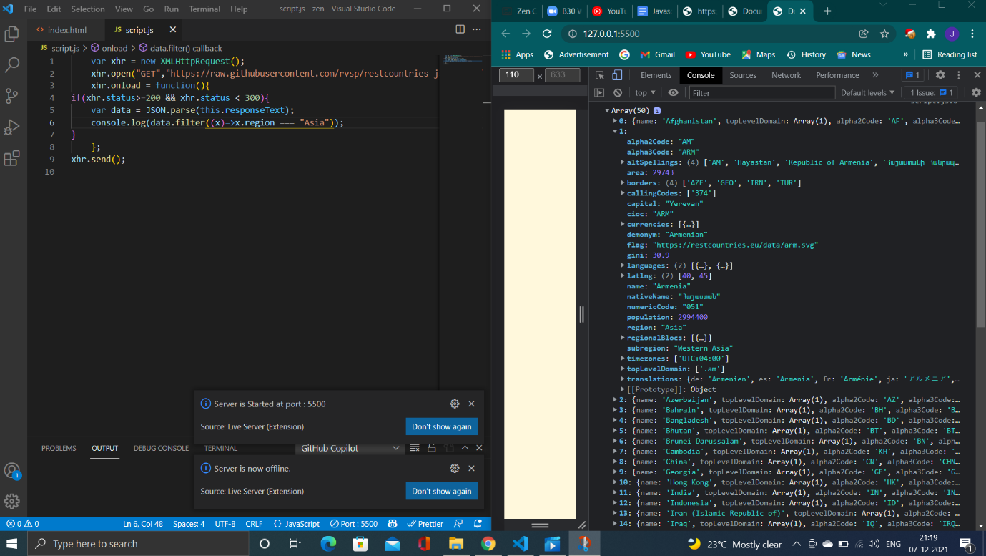

2

    var xhr = new XMLHttpRequest();

    xhr.open("GET","https://raw.githubusercontent.com/rvsp/restcountries-json-data/master/res-countries.json")

    xhr.onload = function(){

if(xhr.status>=200 && xhr.status < 300){

    var data = JSON.parse(this.responseText);

    console.log(data.filter((x)=>x.population <= 200000));

}

    };

xhr.send();

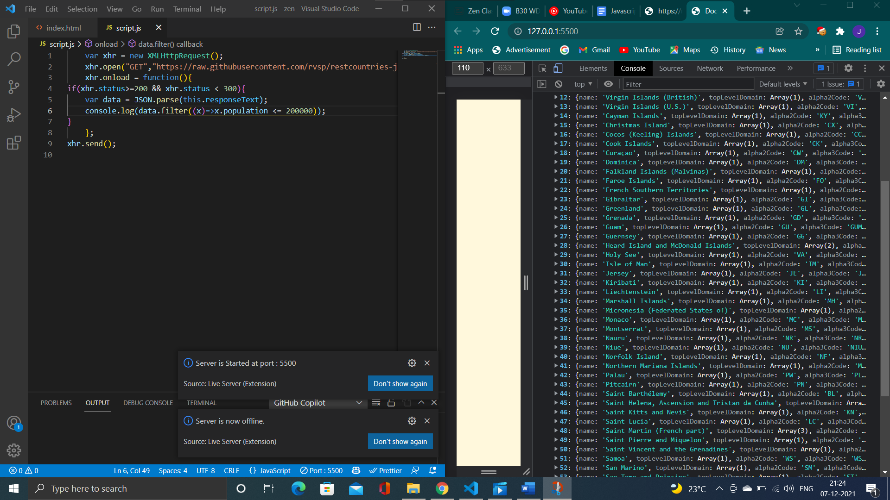

5

var xhr = new XMLHttpRequest();

    xhr.open("GET","https://raw.githubusercontent.com/rvsp/restcountries-json-data/master/res-countries.json")

    xhr.onload = function(){

if(xhr.status>=200 && xhr.status < 300){

    var data = JSON.parse(this.responseText);

    console.log(data.filter((x)=>x.currencies[0].code === "USD"));

}

    };

xhr.send();

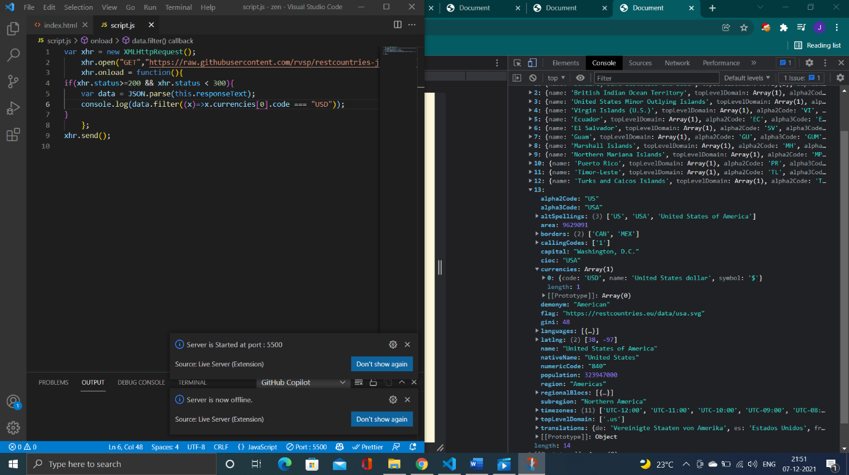

3

var xhr = new XMLHttpRequest();

    xhr.open("GET","https://raw.githubusercontent.com/rvsp/restcountries-json-data/master/res-countries.json")

    xhr.onload = function(){

if(xhr.status>=200 && xhr.status < 300)

{

    var data = JSON.parse(this.responseText);

    data.forEach(function(emp)

    {

        console.log(emp.name),

        console.log(emp.capital),

        console.log(emp.flag)

    //console.log(data.filter((x)=>x.currencies[0].code === "USD"));

})

}

    }

xhr.send();

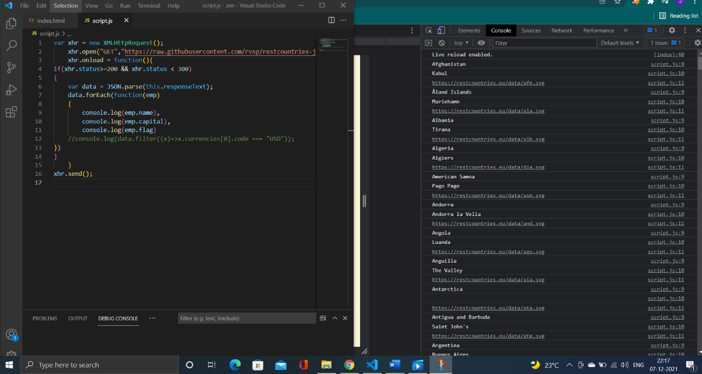

4

var xhr = new XMLHttpRequest();

    xhr.open("GET","https://raw.githubusercontent.com/rvsp/restcountries-json-data/master/res-countries.json")

    xhr.onload = function(){

if(xhr.status>=200 && xhr.status < 300)

{

    var data = JSON.parse(this.responseText);

    let totalpopulation = data.reduce((acc,curr) => {

        return acc + curr.population;

    },0);

    console.log(totalpopulation)

}

    }

xhr.send();

